**How to get the FM Welcome Screen:**

**NOTE: to see the FM Welcome Screen you must have both the following conditions**

1. **Be using the mobile app. FM does not support the Welcome screen in the web app.**
2. **Have clear history with the app. The Welcome Screen only appears on first interaction, so any existing chat needs to be deleted to simulate first interaction. See second section below for details on how to clear chat history.**

**Initial Setup (*this is done, documenting it for future reference)***

* Go to the app page and click on settings:
* 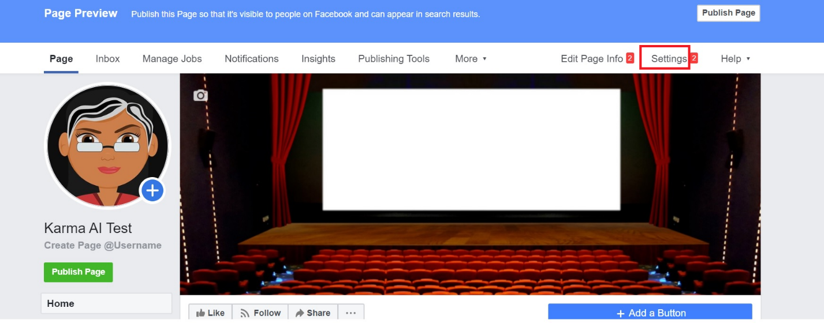
* Click on Settings -> Messaging -> Starting a Messenger Conversation
* In the section that shows, ensure toggle is set to “On” and click “Change” to update the boilerplate text
* 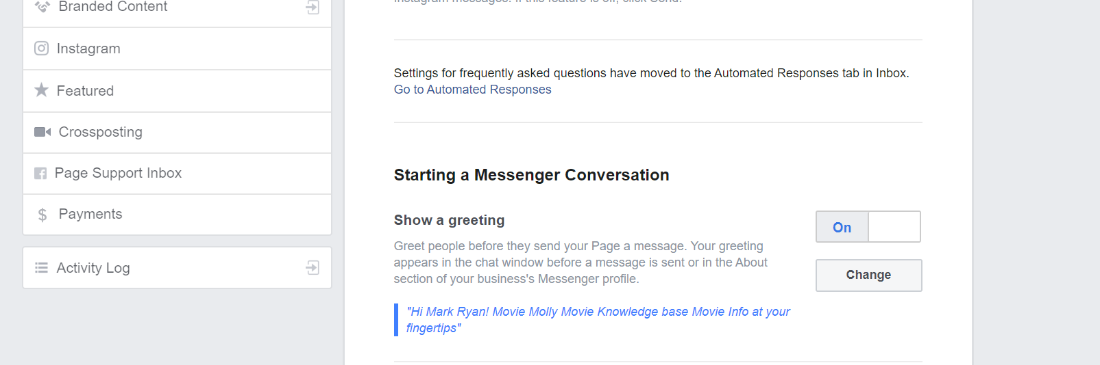

**To see the welcome screen in a chat**

* You must be using the mobile app – you don’t get a welcome screen on the web app
* You must clear out the current conversation with Karma AI Test so you can start a new one:
  + In mobile app, open up your existing conversation with Karma AI Test
  + Select the Movie Molly icon at the top
  + 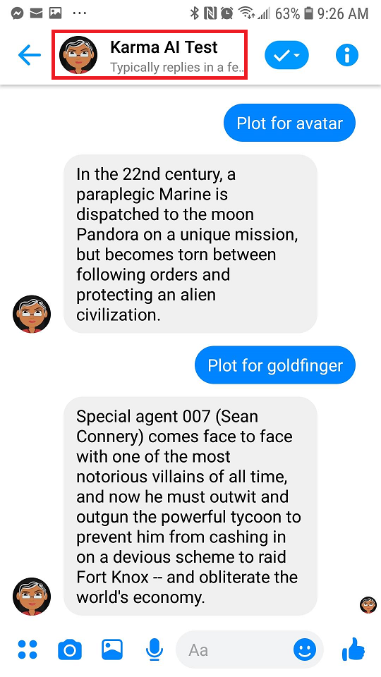
  + This will bring up the Karma AI cover page. Click on the three dots at the top and then select “Delete conversation”
  + 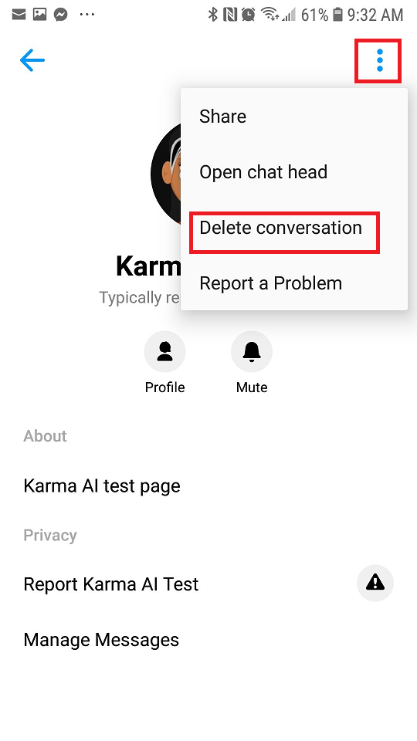
  + Click on “Delete” in the dialog that comes up
  + Now the previous conversation is cleared, search for Karma AI Test again (it should appear under Recent Searches)
  + Select “Karma AI Test” and the Welcome screen will come up:
  + 